Student Registration/Personal Needs Profile
Field Definitions
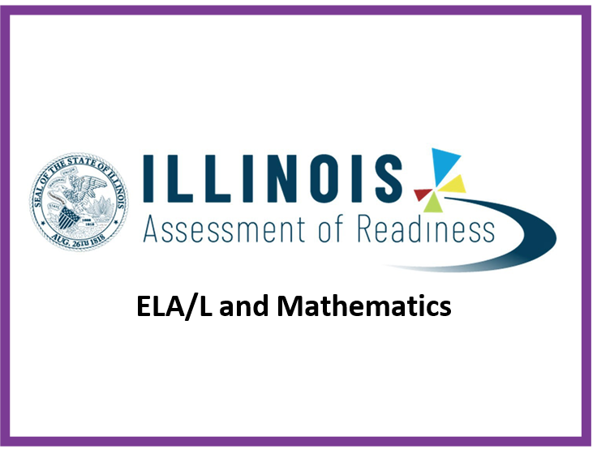
Copyright 2022, Pearson

The purpose of this document is to provide the information needed to populate values in the Student Registration/Personal Needs Profile (SR/PNP) data file and instructions for importing the file into PearsonAccess^{next}. The first section of this document has a checklist of tasks that need to be completed before importing the file, Matching Criteria used to match SR/PNP records to student records currently in PearsonAccess^{next}, step‐by‐step instructions for importing the file into PearsonAccess^{next}, and Helpful Hints. The second section of this document contains a table with the list of fields that will be present in the data file. This table also indicates if the field is required, field length requirements, Field Definitions, Notes/Validations, and expected values or criteria for entering valid values. It also contains Definitions and Notes that provide additional information for particular fields as well as a column with a quick reference to the Accessibility Features and Accommodations (AF&A) Manual when applicable. The Personal Needs Profile (PNP) section is used to gather information regarding a student’s testing condition, materials, or accessibility features and accommodations that may be needed to take the assessment.
Checklist Prior to File Import
1 | Verify student demographic fields used for matching criteria is the same between what is populated in the SR/PNP data file and what is populated currently in PearsonAccess^{next}. | □
2 | Student PNP imports MUST include the State Student Identification number as imported into PearsonAccess^{next} via the ISBE Student Information System (SIS) import. Students not already in PAN, must be updated in SIS first if at all possible prior to testing. | □
3 | Verify that all required fields are populated. Required field rows are highlighted in green. | □
4 | All expected values match the values found in this document. Bolded text in the Expected Values column must be entered exactly as it appears. | □
5 | Do not delete the header row. | □
6 | Import the file as a Comma Delimited File (.csv file extension) or Fixed File (.txt file extension). | □
The following icon appears in the PNP section of this document. This icon will indicate which testing conditions, materials, or accessibility features and accommodations are available/compatible with computer‐based tests (CBT), paper‐based tests (PBT), ELA/L, and/or mathematics.
CBT
PBT
ELA/L Math
Important

Read the Definitions and Notes carefully to prevent records from encountering cross‐validation errors.
If a student has more than one test assignment (e.g., Grade 8 ELA/Literacy and Mathematics Grade 8), each test assignment needs to appear as a separate record on the SR/PNP Import File. For example, if a student is taking Grade 8 ELA/Literacy and Mathematics Grade 8, this student will have two records on the SR/PNP Import File (one for each test assignment).
An option allows users to decide whether test sessions are auto‐created and tests assigned to them or not during the SR/PNP import process. The Don't auto‐create Test Sessions for online testing option appears on the Import/Export Task screen option and when checked, test sessions will not be auto created and tests assigned to them. Online test sessions will automatically be created and students added to them if the Session Name field is populated and Don't auto‐create Test Sessions for online testing option on the import task screen is unchecked. If the Session Name field is left blank, online test sessions can be auto‐created at a later time by importing an updated SR/PNP or sessions will need to be manually created and students manually added to them in PearsonAccess^{next}. There are two options to move students to different test sessions: 1. Users can manually move students to different session through the user interface, or 2. Users can remove students from the current test sessions and then import a SR/PNP with updated Session Name field values. If students are currently assigned to a test session, then updating the Session Name field and re‐importing the SR/PNP will not move students to new sessions or update the current session name. A SR/PNP can be used to add students to existing sessions that are not prepared, prepared, or started.
Students requiring a computer‐based read‐aloud test must be placed in specific read‐aloud test sessions. To do this, change the Session Name field to a different value to automatically place students requiring a read‐aloud computer‐based test in a separate session(s). Once created, the sessions will need the form group type manually switched to Human Reader under Edit Sessions screen in PearsonAccess^{next}.
Students registered for a computer‐based Human Reader or Human Signer Mathematics Test or computer‐based Spanish Human Reader or Human Signer Mathematics Test will be shipped a paper human reader/signer script if recorded before the test registration window ends. The test administrator will use this script in conjunction with computer‐based Human Reader or Human Signer Mathematics Tests. Make sure to place students in a Human Reader or Human Signer Test Session. An additional order will need to be placed for scripts if the enrollment deadline is missed.
Helpful Hints:
- If using Microsoft Excel and a .csv file, it is recommended that the source file is saved as an Excel spreadsheet to keep formatting. Prior to each import attempt, save the data file as an Excel spreadsheet. Then save again as a .csv file. If an error is encountered, make the updates in the source Excel spreadsheet and save, and then save again as a .csv file. Repeat as necessary.
- A file may contain records with or without errors. The records without errors will be imported into PearsonAccess^{next}. Records with errors will need to be corrected and re‐imported into PearsonAccess^{next}. If errors are discovered, the initial import file may be reused by leaving the records without errors in the file, and correcting only the records with errors. When re‐importing this file, PearsonAccess^{next} will treat the records without errors as updates, even if no values changed. This will not cause any issues.

Student Matching Rules
When student data is imported into PearsonAccess^{next}, demographic fields are used to identify unique students. When data is updated in PearsonAccess^{next}, matching rules are applied to these fields to identify if records currently exist within the system. This information will be important for importing SR/PNP files for the IAR as many students already exist within PearsonAccess^{next} from the previous administrations. The table below provides information on the fields used for matching and can be updated through an SR/PNP Import.

How Matching Works?
Record will match if State Student Identifier and at least three of the following Core Demographic Fields match:
- Full Last Name
- Full First Name
- Middle Name
- Gender
- Date of Birth

ISBE’s Student Information System (SIS)
Student Registration Information will come from ISBE’s Student Information System (SIS) via direct feeds from ISBE SIS. The initial import will be in early January. Any student demographic changes after that date will be sent from SIS to PearsonAccess^{next} nightly. Districts or Schools may also request that changes be immediately pushed to PearsonAccess^{next} through IWAS/SIS. Fields that are driven by SIS will overwrite any changes that have been made to student demographics in PearsonAccess^{next} . These fields are designated in the layout in the “SIS Field” column with a “Y”. It is important to make sure that SIS is always the most accurate information for these fields.
IMPORTANT: When using the PearsonAccess^{next} student registration import to update accommodations, fields previously populated via the SIS import OR fields previously populated in PearsonAccess^{next} need to be included with the current values to prevent unintentional blanking out of values in PAN. It is recommended to start with a Student Registration export to capture current values prior to adding accommodations and re‐importing the file. Importing a file with blanks for the fields initially imported from SIS in January (i.e. race/ethnicity, migrant status, etc.) will overwrite these fields and cause critical errors in the registration fields. These critical errors will not prevent students from testing but should accurately reflect information in SIS, which is the source of truth for student demographics. Importing blanks for accommodations fields that were previously populated in PearsonAccess^{next} will overwrite those accommodations.

Importing a SR/PNP Data File
- Log into PearsonAccess^{next}.
- Select the admin from the admin drop down menu on the top of the screen (IAR Spring 2022).
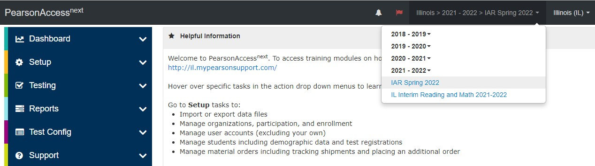
- From the SETUP section select Import/Export Data.
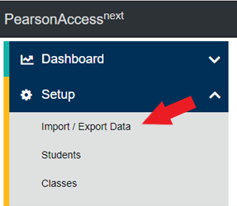

- In the Select Tasks dropdown menu, select Import/Export Data.
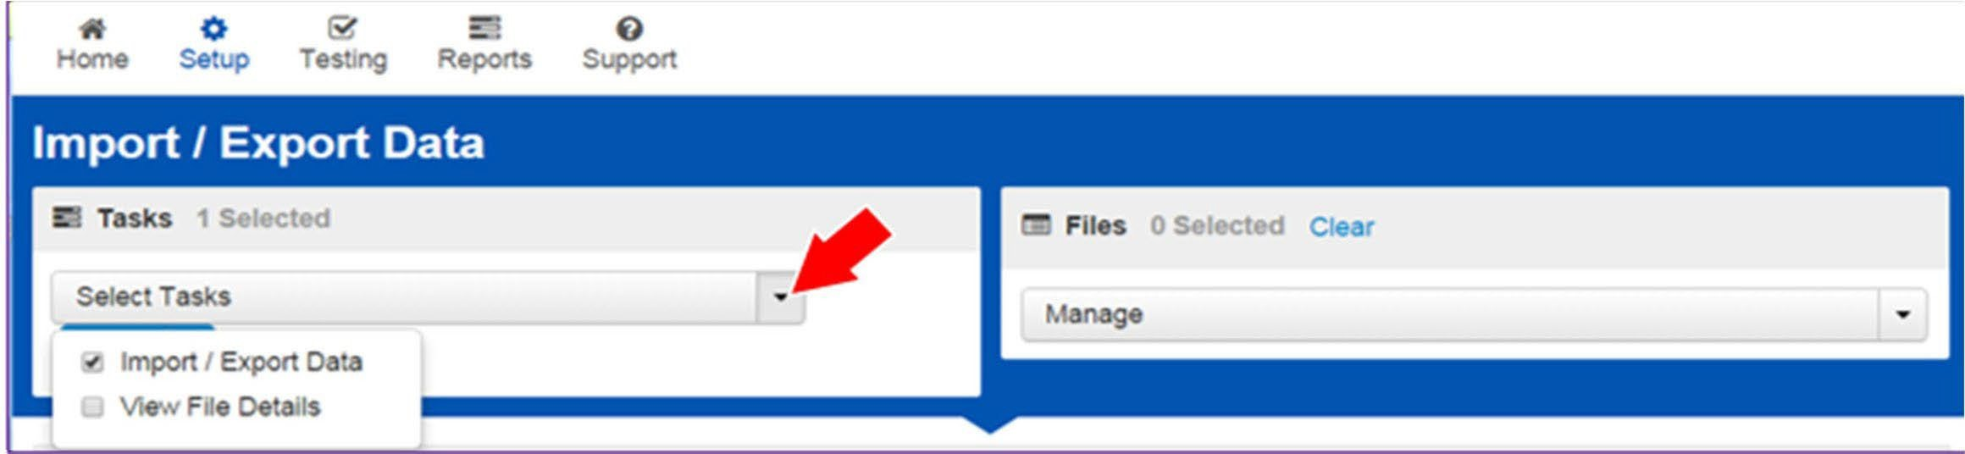
- Select Start.
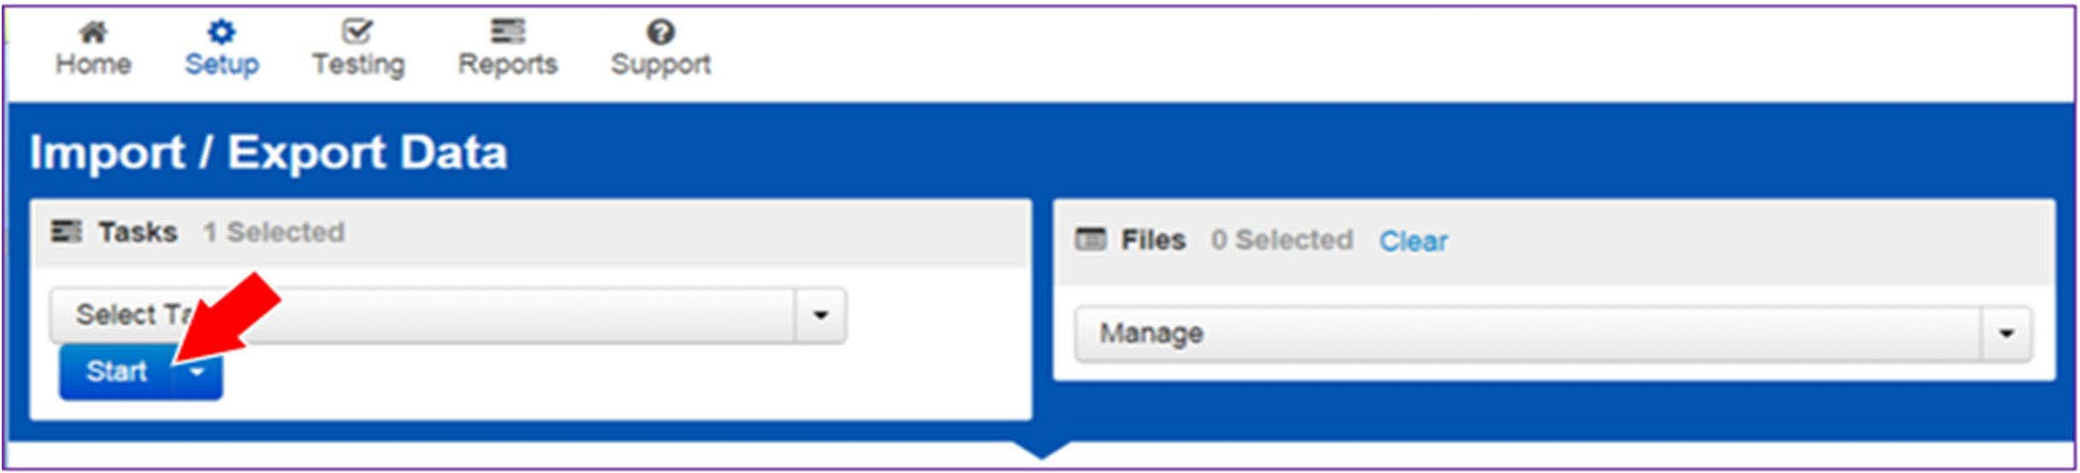
- First select Student Registration Export to capture the student demographics information, then when ready select Student Registration Import from the dropdown menu.
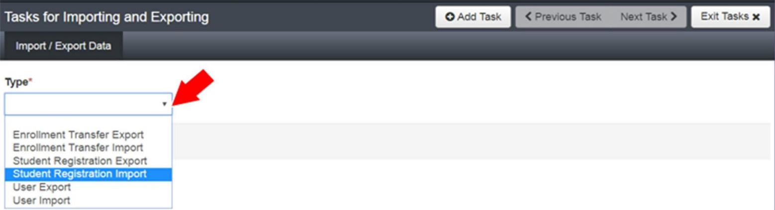
- In the File Layout Type dropdown menu, select the type of file to be imported (.csv or Fixed).
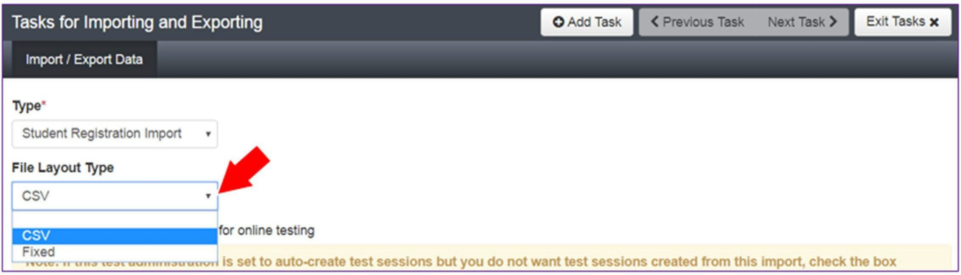
- Review options for File Import.
  - This option allows users to decide if they would like to auto‐create and assign tests to test sessions.
  - DO NOT select the Don’t modify student tests. This option should only be selected when updating existing student demographic data without updating test registration data.
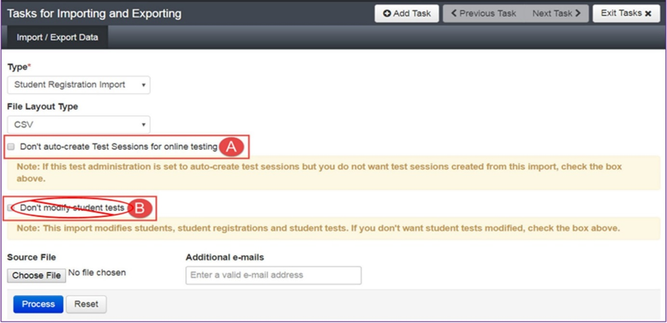
- Choose File to select the file to import.
- Once you see the correct .csv file listed, click Process to submit the selected file.

Checking the status of an imported file
The View File Details screen will appear after selecting Process. This screen will show the processing status. Select the refresh icon to refresh the screen.
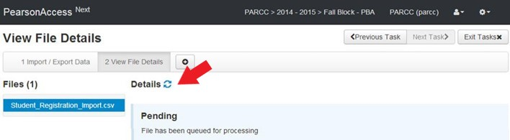
After the file processes, the View File Details screen will show a Complete message, and the number of Successful Records processed will be indicated. The number of Error Records processed will also be indicated.
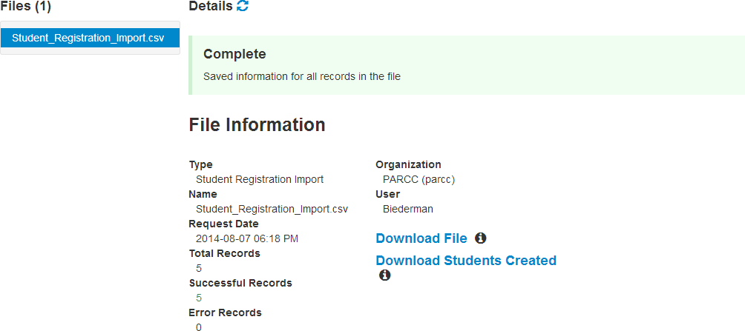If there are errors, they will be displayed at the bottom of the screen. There is an option to download a file with just the records that contained an error in order to resolve these records and import them. There is also an option to view a list of error messages (without the records).
Sample School
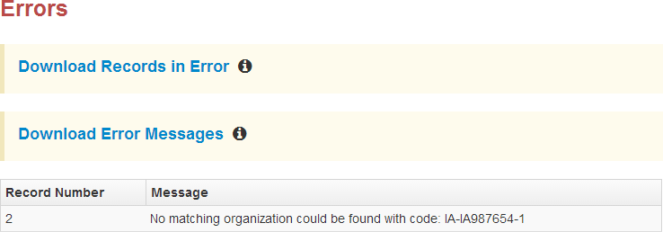Helpful Hint:
A file may contain records with or without errors. The records without errors will be imported into PearsonAccess^{next}. Records with errors will need to be corrected and re‐imported into PearsonAccess^{next}. The initial import file may be reused by leaving the records without errors in the file, and correcting only the records with errors. When re‐importing this file, PearsonAccess^{next} will treat the records without errors as updates, even if no values changed. This will not cause any issues. Alternatively, the user may choose to import only those records that were in error.

Column  Letter | Field Name | Required  Y/N | Field Length | Field Definitions | Field Notes and Valtidations | Expected Values | SIS‐ Fields* Y = SIS will over‐ride PAN | AF&A  Manual Reference
A | State Abbreviation | N | 2 | State’s 2 character abbreviation | Not applicable | IL | Y | Not applicable
B | Testing District Code | Y | 15 | The Testing District responsible for administering the test for a student. | Error and reject record if organization does not exist and set to participate in administration within PearsonAccess^{next}. | A‐Z, 0‐9 | Y | Not applicable
C | Testing School Code | Y | 15 | The Testing School responsible for administering the test for a student. | Error and reject record if organization does not exist and set to participate in administration within PearsonAccess^{next}. | A‐Z, 0‐9 | Y | Not applicable
D | Home District Code | N | 15 | The district responsible for specific educational services and/or instruction of the student. | Only populate this field if the Responsible District is different than Testing District. If this field is left blank, it is assumed the Testing District is also the Accountable District.  Error and reject record if organization does not exist and set to participate in administration within PearsonAccess^{next}. | A‐Z, 0‐9  Blank | Y | Not applicable
E | Home School Code | N | 15 | A unique number or alphanumeric code assigned to an institution by a school, school system, a state, or other agency or entity. | Only populate this field if the Responsible School is different than Testing School. If this field is left blank, it is assumed the Testing School is also the Accountable School.  School reporting to a District  Error and reject record if organization does not exist and set to participate in administration within PearsonAccess^{next}. | A‐Z, 0‐9  Blank | Y | Not applicable
Core Student Data

F | State Student Identifier | Y | 10 | A unique number or alphanumeric code assigned to a student by ISBE. | State Student Identifier needs to be unique by student. SSID’s from ISBE’s SIS will be 9 bytes.  Temporary SSIDs for students created in PAN will be 10 bytes until matched with the appropriate SIS Student ID. | 0‐9  No embedded spaces | Y | Not applicable
G | Local Student Identifier | N | 30 | A unique number or alphanumeric code assigned to a student by a school system or any other entity. | Not applicable | A‐Z  0‐9  No embedded spaces  Blank | Y | Not applicable
H | Unique Pearson Student ID | N | 36 | Unique Pearson Student ID that is used for growth analysis across years. | Assigned within PearsonAccess^{next}. |  | Y
I | Last or Surname | Y | 35 | The full legal last name borne in common by members of a family. | Not applicable | A‐Z  0‐9  .  ‐  ' (Standard Apostrophe) Embedded Spaces | Y | Not applicable
J | First Name | Y | 35 | The full legal first name given to a person at birth, baptism, or through legal change. | Not applicable | A‐Z  0‐9  .  ‐  ' (Standard Apostrophe) Embedded Spaces | Y | Not applicable
K | Middle Name | N | 35 | A full legal middle name given to a person at birth, baptism, or through legal change. | Not applicable | A‐Z  0‐9  .  ‐  ' (Standard Apostrophe) Embedded Spaces Blank | Y | Not applicable

L | Birthdate | Y | 10 | The year, month and day on which a person was born. | Not applicable | YYYY‐MM‐DD  0‐9  − / | Y | Not applicable
M | Sex | Y | 1 | The concept describing the biological traits that distinguish the males and females of a species. | Not applicable | F = Female  M = Male  N = Non‐Binary | Y | Not applicable
N | State Field 1 | N | 20 | Not applicable | Leave blank unless you receive other direction from your state. | A‐Z  0‐9  .  ‐  ' (Standard Apostrophe) Embedded Spaces Blank | Y | Not applicable
Student Registration (Administration‐level Data)
Column  Letter | Field Name | Required  Y/N | Field  Length | Field Definitions | Field Notes and Validations | Expected Values | SIS‐ Fields* Y = SIS will over ride PAN | AF&A  Manual Reference
O | Grade Level When Assessed | Y | 2 | The grade or developmental level of a student when assessed. | Not applicable | 03 = Third grade  04 = Fourth grade 05 = Fifth grade 06 = Sixth grade  07 = Seventh grade  08 = Eighth grade | Y | Not applicable
P | Hispanic or Latino Ethnicity | N | 1 | An indication that the person traces his or her origin or descent to Mexico, Puerto Rico, Cuba, Central and South America, and other Spanish cultures, regardless of race. | This field is not required during import of student data, but if left blank, this field will create a Critical Warning in PearsonAccess^{next}. | Y = Yes  N = No  Blank | Y | Not applicable
Q | American Indian or Alaska Native | N | 1 | A person having origins in any of the original peoples of North and South America (including Central America), and who maintains cultural identification through tribal affiliation or community attachment. | This field is not required during import of student data. A Critical Warning will appear in PearsonAccess^{next} if no race fields (Columns Q‐W) have an expected value entered. | Y = Yes  N = No  Blank | Y | Not applicable
R | Asian | N | 1 | A person having origins in any of the original peoples of the Far East, Southeast Asia, or the Indian Subcontinent. This area includes, for example, Cambodia, China, India, Japan, Korea, Malaysia, Pakistan, the Philippine Islands, Thailand, and Vietnam. | This field is not required during import of student data. A Critical Warning will appear in PearsonAccess^{next} if no race fields (Columns Q‐W) have an expected value entered. | Y = Yes  N = No  Blank | Y | Not applicable
S | Black or African American | N | 1 | A person having origins in any of the black racial groups of Africa. | This field is not required during import of student data. A Critical Warning will appear in PearsonAccess^{next} if no race fields (Columns Q‐W) have an expected value entered. | Y = Yes  N = No  Blank | Y | Not applicable
T | Native Hawaiian or Other Pacific Islander | N | 1 | A person having origins in any of the original peoples of Hawaii, Guam, Samoa, or other Pacific Islands. | This field is not required during import of student data. A Critical Warning will appear in PearsonAccess^{next} if no race fields (Columns Q‐W) have an expected value entered. | Y = Yes  N = No  Blank | Y | Not applicable
U | White | N | 1 | A person having origins in any of the original peoples of Europe, Middle East, or North Africa. | This field is not required during import of student data. A Critical Warning will appear in PearsonAccess^{next} if no race fields (Columns Q‐W) have an expected value entered. | Y = Yes  N = No  Blank | Y | Not applicable
V | Blank Field | N | 1 | Not applicable | Note this field is being used as a placeholder for possible future data field. | N/A | Y | Not applicable
W | Two or More Races | N | 1 | A person having origins in any of more than one of the racial groups. | This field is not required during import of student data. A Critical Warning will appear in PearsonAccess^{next} if no race fields (Columns Q‐W) have an expected value entered. | Y = Yes  N = No  Blank | Y | Not applicable
X | English Learner (EL) | N | 1 | English Learner (EL) | This field is not required during import of student data, but if left blank, this field will create a Critical Warning in PearsonAccess^{next}. | Y = Yes  N = No  Blank | Y | Not applicable
Y | Title III Limited English Proficient Participation Status | N | 1 | An indication that a limited English proficient (LEP) student is served by an English language instruction educational program supported with Title III of ESEA funds. | This field is not required during import of student data, but if left blank, this field will create a Critical Warning in PearsonAccess^{next}. | Y = Yes  N = No  X = Not Collected or N/A  Blank | Y | Not applicable
Z | Gifted and Talented | N | 1 | An indication that the student is participating in and served by a Gifted/Talented program. | This field is not required during import of student data, but if left blank, this field will create a Critical Warning in PearsonAccess^{next}. | Y = Yes  N = No  X = Not Collected or N/A  Blank | Y | Not applicable
AA | Migrant Status | N | 1 | Persons who are, or whose parents or spouses are, migratory agricultural workers, including migratory dairy workers, or migratory fishers, and who, in the preceding 36 months, in order to obtain, or accompany such parents or spouses, in order to obtain, temporary or seasonal employment in agricultural or fishing work (A) have moved from one LEA to another; (B) in a state that comprises a single LEA, have moved from one administrative area to another within such LEA; or (C) reside in an LEA of more than 15,000 square miles, and migrate a distance of 20 miles or more to a temporary residence to engage in a fishing activity. | This field is not required during import of student data, but if left blank, this field will create a Critical Warning in PearsonAccess^{next}. | Y = Yes  N = No  Blank | Y | Not applicable
AB | Economic Disadvantage Status | N | 1 | An indication that the student met the State criteria for classification as having an economic disadvantage. | This field is not required during import of student data, but if left blank, this field will create a Critical Warning in PearsonAccess^{next}. | Y = Yes  N = No  Blank | Y | Not applicable
AC | Student With Disabilities | N | 3 | If a student has a disability and an IEP, they are automatically covered by Section 504. If a student has an IEP and needs academic interventions, this should be included in their IEP. The IEP is required to address ALL of a student’s needs that are related to the disability. | IEP = Student has IEP  504 = Student has 504 Plan B = Both IEP and 504  N = Student does not have IEP or 504 plan  This field is not required during import of student data, but if left blank, this field will create a Critical Warning in PearsonAccess^{next} | IEP  504  B = Both IEP and 504  N = No  Blank | N | Not applicable
AD | Primary Disability Type | N* | 3 | The major or overriding disability condition that best describes a person's impairment. | *This field is ONLY required if Student With Disabilities field equals “IEP” or “B”.  Only users with the Sensitive Data and/or Student Test Update Add‐on Role will be able to view/update this field after students have been imported into PearsonAccess^{next}.  NC = Not Collected is acceptable by ISBE. | AUT = Autism DB = Deaf‐ blindness  DD =  Developmental delay  EMN = Emotional disturbance  HI = Hearing impairment  ID = Intellectual Disability  MD = Multiple disabilities  NC = Not Collected OI = Orthopedic impairment  OHI = Other health impairment  SLD = Specific learning disability SLI = Speech or language impairment  TBI = Traumatic brain injury  VI = Visual impairment Blank | N | Not applicable
AE | State Field 2 | N | 20 | Not applicable | Leave blank unless you receive other direction from ISBE. | A‐Z  0‐9  .  ‐  ' (Standard Apostrophe) Embedded Spaces Blank | Y | Not applicable

AF | State Field 3 | N | 20 | Not applicable | Leave blank unless you receive other direction from ISBE. | Leave blank unless you receive other direction from ISBE. | Y | Not applicable
AG | State Field 4 | N | 20 | Not applicable | Leave blank unless you receive other directions from ISBE. | Leave blank unless you receive other direction from ISBE. | Y | Not applicable
AH | State Field 5 | N | 20 | Not applicable | Leave blank unless you receive other direction from ISBE. | A‐Z  0‐9  .  ‐  ' (Standard Apostrophe) Embedded Spaces Blank | Y | Not applicable
AI | State Field 6 | N | 20 | Not applicable | Leave blank unless you receive other direction from ISBE. | A‐Z  0‐9  .  ‐  ' (Standard Apostrophe) Embedded Spaces Blank | Y | Not applicable

AJ | State Field 7 | N | 20 | Not applicable | Leave blank unless you receive other direction from ISBE. | A‐Z  0‐9  .  ‐  ' (Standard Apostrophe) Embedded Spaces Blank | Y | Not applicable
AK | State Field 8 | N | 20 | Not applicable | Leave blank unless you receive other  direction from ISBE. | A‐Z  0‐9  .  ‐  ' (Standard Apostrophe) Embedded Spaces Blank | Y | Not applicable
AL | State Field 9 | N | 20 | Not applicable | Leave blank unless you receive other direction from ISBE. | A‐Z  0‐9  .  ‐  ' (Standard Apostrophe) Embedded Spaces Blank | Y | Not applicable
AM | State Field 10 | N | 20 | Not applicable | Leave blank unless you receive other direction from ISBE. | A‐Z  0‐9  .  ‐  ' (Standard Apostrophe) Embedded Spaces Blank | Y | Not applicable
AN | State Field 11 | N | 20 | Not applicable | Leave blank unless you receive other direction from ISBE. | A‐Z  0‐9  .  ‐  ' (Standard Apostrophe) Embedded Spaces Blank | Y | Not applicable
AO | State Field 12 | N | 20 | Not applicable | Leave blank unless you receive other direction from ISBE. | A‐Z  0‐9  .  ‐  ' (Standard Apostrophe) Embedded Spaces Blank | Y | Not applicable
AP | State Field 13 | N | 20 | Not applicable | Leave blank unless you receive other direction from ISBE. | A‐Z  0‐9  .  ‐  ' (Standard Apostrophe) Embedded Spaces Blank | Y | Not applicable
AQ | State Field 14 | N | 20 | Not applicable | Leave blank unless you receive other direction from ISBE. | A‐Z  0‐9  .  ‐  ' (Standard Apostrophe) Embedded Spaces Blank | Y | Not applicable
AR | State Field 15 | N | 20 | Not applicable | Leave blank unless you receive other direction from ISBE. | A‐Z  0‐9  .  ‐  ' (Standard Apostrophe) Embedded Spaces Blank | Y | Not applicable

AP | State Field 13 | N | 20 | Not applicable | Leave blank unless you receive other  direction from ISBE. | A‐Z  0‐9  .  ‐  ' (Standard Apostrophe) Embedded Spaces Blank | Y | Not applicable
AQ | State Field 14 | N | 20 | Not applicable | Leave blank unless you receive other  direction from ISBE. | A‐Z  0‐9  .  ‐  ' (Standard Apostrophe) Embedded Spaces Blank | Y | Not applicable
AR | State Field 15 | N | 20 | Not applicable | Leave blank unless you receive other  direction from ISBE. | A‐Z  0‐9  .  ‐  ' (Standard Apostrophe) Embedded Spaces Blank | Y | Not applicable
jklTest Registration (Test-level Data)
Column  Letter | Field Name | Required  Y/N | Field  Length | Field Definitions |  | Field Notes and Validations |  | Expected Values |  | SIS‐  Fields* Y = SIS  will over‐ride PAN | AF&A  Manual Reference
AS | Session Name | N | 50 | The description of the place where an assessment is administered. |  | For computer‐based testing: If this field is populated on an import the session will be auto‐created and the student's test will be placed into the named session. If students are already in test sessions, students must be removed from current test sessions prior to importing an updated SR/PNP.  Students requiring a read aloud computer‐based test should be placed in specific read aloud test sessions.  For paper‐based testing:  If this field is populated on an import prior to the enrollment window closing and the test format is paper, then this will be used for sorting and rostering of student and their test book labels. |  | A‐Z  a‐z 0‐9  ‐  ' (Standard Apostrophe) embedded spaces Blank |  | N | Not applicable
AT | Class Name | N | 45 | The name of a group of students. |  | This field can be used to add students to test sessions by groups (i.e. Class Name) through the user interface. |  | A‐Z  a‐z 0‐9  ‐  ' (Standard Apostrophe).  )  (  &  /  +  embedded spaces Blank |  | N | Not applicable
AU | Test Administrator | N | 30 |  | Test Administrator is the person overseeing the student(s) in a test session. |  | Not applicable |  | A‐Z  a‐z  ‐  ' (Standard Apostrophe)  .  )  (  &  /  +  0‐9 embedded spaces Blank | N |  | Not applicable
AV | Staff Member Identifier | N | 30 |  | A unique number or alphanumeric code assigned to a staff member by a school, school system, a state, registry, or other agency or entity. |  | Not applicable |  | A‐Z  a‐z  ‐  ' (Standard Apostrophe)  .  )  (  &  /  +  0‐9 embedded spaces Blank | N |  | Not applicable

AW | Test Code | Y | 5 | Identifier assigned to the test  name. | Not applicable | ELA03 = Grade 3  ELA/L  ELA04 = Grade 4 ELA/L  ELA05 = Grade 5 ELA/L  ELA06 = Grade 6 ELA/L  ELA07 = Grade 7 ELA/L  ELA08 = Grade 8 ELA/L  MAT03 = Grade 3 Math  MAT04 = Grade 4 Math  MAT05 = Grade 5 Math  MAT06 = Grade 6 Math  MAT07 = Grade 7 Math  MAT08 = Grade 8 Math | Y | Not applicable
AX | Test Format | Y | 1 | Format of the Test | Paper = Paper‐based Testing (PBT)  Online = Computer‐based Testing (CBT)  Initial student load from SIS will default to Online; If paper tester, value must be switched to P by District/School. | P = Paper  O = Online | N  *Default is Online | Not applicable
AY | Retest | N | 1 | Indicates if this registration is for  a retest (retake). Retest can occur if a student failed a prior attempt and is eligible to retake. Other retest scenarios also can occur. | Indicates if the student is retaking the  test. | Y = Yes  N = No  Blank | N | Not applicable
AZ | Blank Field | N | 1 | N/A | Note this field is being used as a  placeholder for possible future data field. | N/A | N | Not applicable

Administration Considerations
Column  Letter | Field Name | Required  Y/N | Field  Length | Field Definitions | Field Notes and Validations | Expected Values | SIS‐  Fields* Y = SIS  will over‐ride PAN | AF&A  Manual Reference
BA | Frequent Breaks  CBT PBT  ELA/L Math | N | 1 | Student is allowed to take breaks, at their request, during the testing session. | Proctor/School Provided Administration Considerations | Y = Yes  Blank | N | 2f
BB | Separate/Alternate Location  CBT PBT  ELA/L Math | N | 1 | Student tested in specially assigned location. | Proctor/School Provided Administration Considerations | Y = Yes  Blank | N | 2c
BC | Small Group Testing  CBT PBT  ELA/L Math | N | 1 | Student is tested in a separate location as an individual or with a small group of students with matching accessibility features, accommodations, or testing needs as appropriate. Check individual state policies on the maximum number of students that are allowed in a small testing group. | Proctor/School Provided Administration Considerations | Y = Yes  Blank | N | 2a
BD | Specialized Equipment or  Furniture  CBT PBT  ELA/L Math | N | 1 | Student is provided specialized equipment or furniture needed for a successful testing environment (e.g., low lighting; adaptive seat). | Proctor/School Provided Administration Considerations | Y = Yes  Blank | N | 2e
BE | Specified Area or Setting  CBT PBT  ELA/L Math | N | 1 | Student is tested in a specialized area or setting (e.g., front of the classroom; seat near the door; library, etc.). | Proctor/School Provided Administration Considerations | Y = Yes  Blank | N | 2d
BF | Time of Day  CBT PBT  ELA/L Math | N | 1 | Student is tested during a specific  time of day based on their individual needs (e.g., ELA/Literacy in the morning; no testing after lunch). | Proctor/School Provided  Administration Considerations | Y = Yes  Blank | N | 2b

Accessibility Features Identified in Advance
These accessibility features are available to all students and not limited to students with disabilities or English Learners.
Column  Letter | Field Name | Required  Y/N | Field  Length | Field Definitions | Field Notes and Validations | Expected Values | SIS‐Fields* Y = SIS will over‐ride PAN | AF&A Manual Reference
BG | Answer Masking  CBT PBT  ELA/L Math | N | 1 | Specifies as part of an Assessment Personal Needs Profile the type of masks the user is able to create to cover portions of the question until needed. | For Computer‐based Testing:  Used to assign this accessibility feature for computer‐based testing.  By default, answer choices for multiple‐ choice items are covered when the item is first presented. The student has the ability to remove the masks at a time of their choosing.  This is available to ALL students taking computer‐based tests and is available on all test forms.  For Paper‐based Testing: Specifies as part of an Assessment Personal Needs Profile the typeof masks the student is able to use to cover answers until needed. | Y = Yes  Blank | BG | Answer Masking  CBT PBT  ELA/L Math
BH | Student Reads  Assessment Aloud to Self  CBT PBT  ELA/L Math | N | 1 | The student reads the assessment aloud to themselves and may use an external device such as a whisper phone. The student must be tested in a separate setting. | Not applicable | Y = Yes  Blank | N | 1q
BI | Color Contrast  CBT PBT  ELA/L Math | N | 2 | Defines as part of an Assessment Personal Needs Profile the access for preference to invert the foreground and background colors. | For Computer‐based Testing:  The interface launches a pre‐selected alternate color combination for the text (foreground) and background colors.  This is available to ALL students testing and is available on all test forms.  If expected value equals “01”‐“06”; then the student must have Test Format populated with "O" or record will error.  For Paper‐based Testing:  Colored overlays for background color. Font color cannot be changed.  Proctor/School‐provided Accommodation  If expected value equals “07”; then the student must have Test Format populated with "P" or record will error. | 01 = black font  on cream background  02 = black font on light blue background  03 = black font  on light magenta background  04 = white font on black background  05 = yellow font on blue background  06 = low contrast color, dark gray font on pale green background  07 = locally provided color overlay for the student to place over their paper test | N | 1d
BJ | ASL Video  CBT  ELA/L Math | N | 1 | Used to assign the form  administered for computer‐based testing. American Sign Language content is provided to the student by a human signer through a video.  If ASL Video is populated for an ELA/L test, an accommodation reminder will be displayed stating: "Adding ASL Video to an ELA/L test without proper documentation may result in the student’s test being invalidated.” Reminders cannot be cleared. | If expected value equals “Y”; then the  following criteria must be met or record will error:  - Test Format populated with "O",  - Student with Disabilities populated with either “504”, “IEP”, OR “B”,  - Assistive Technology ‐ Screen Reader must be left blank,  - Assistive Technology ‐ Non‐Screen Reader must be left blank,  - Closed Captioning for ELA/L must be left blank,  - Spanish Transadaptation of the Mathematics Assessment must be left blank,  - Text‐to‐Speech must be leftblank,  and Human Reader or Human Signer must be left blank. | Y = Yes  Blank | N | 3j ‐ELA/L  3l ‐ Math
BK | Assistive Technology ‐ Screen Reader  CBT  ELA/L Math | N | 1 | Used to assign the form  administered for computer‐based testing.  Assistive Technology ‐ Screen Reader ‐ Screen Reader Assistive Technology Application (Examples: Jaws, NVDA) used to deliver computer‐based test form for ELA/L and Math. Delivers form tagged to support Screen Reader use.  Screen Reader Application used to deliver computer‐based test form for ELA/L and Math.  Screen Reader Assistive Technology is a 3rd party external support intended for students who are blind. The Screen Reader is used for browser navigation and access to content. Examples: Jaws, NVDA. It can also be used in combination with a Refreshable Braille device for access and response. | If expected value equals “Y”; then the  following criteria must be met or record will error:  - Test Format populated with "O",  - Student with Disabilities populated with either “504”, “IEP”, OR “B”,  - ASL Video must be left blank,  - Assistive Technology ‐ Non‐Screen Reader must be left blank,  - Closed Captioning for ELA/L must be left blank,  - Spanish Transadaptation of the Mathematics Assessment must be left blank,  - Text‐to‐Speech must be left blank,  - and Human Reader or Human Signer must be left blank.  Note: If Assistive Technology ‐ Screen Reader value equals “Y” then a full Braille book including Tactile Graphics will be shipped automatically if the specific computer‐based test images or graphics must be represented by tactile graphics. If a student is enrolled for Assistive Technology ‐ Screen Reader after the enrollment window is closed then an additional order will need to be submitted. | Y = Yes  Blank | N | 3b
BL | Assistive Technology ‐  Non‐Screen Reader  CBT  ELA/L Math | N | 1 | Used to assign the form administered for computer‐based testing when an assistive technology application is needed for students without visual impairments.  Assistive Technology ‐ Non‐Screen Reader ‐ Assistive Technology Application (Examples: Co:Writer, Read&Write Gold ) used to deliver computer‐based test form for ELA/L and Math.  Assistive technology that provides magnification or word prediction assistive technology support that requires security pass through to interact with TestNav. | If expected value equals “Y”; then the  following criteria must be met or record will error:  - Test Format populated with "O",  - Student with Disabilities populated with either “504”, “IEP”, OR “B”,  - ASL Video must be left blank,  - Assistive Technology ‐ Screen Reader must be left blank,  - Closed Captioning for ELA/L must be left blank,  - Spanish Transadaptation of the Mathematics Assessment must be left blank,  - Text‐to‐Speech must be left blank, and Human Reader or Human Signer must be left blank. | Y = Yes  Blank | N | 3a  4a
BM | Closed Captioning for  ELA/L  ELA/L | N | 1 | Used to assign the form administered for computer‐based testing.  Closed captioning and subtitling are both processes of displaying text on a television, video screen, or other visual display to provide additional or interpretive information. | If expected value equals “Y”; then the  following criteria must be met or record will error:  - Test Format populated with "O",  - Test Code must be populated with a ELA/L Subject,  - Student with Disabilities populated with either “504”, “IEP”, OR “B”,  - ASL Video must be left blank,  - Assistive Technology ‐ Screen Reader must be left blank,  - Assistive Technology ‐ Non‐Screen Reader must be left blank,  - Text‐to‐Speech must be left blank,  and Human Reader or Human Signer must be left blank. | Y = Yes  Blank | N | 3h
BN | Refreshable Braille  Display for ELA/L  ELA/L | N | 1 | Used to assign a computer‐based form for Braille in conjunction with Screen Reader.  Student uses external device which converts the text from the Screen Reader into Braille. | If expected value equals “Y”; then the  following criteria must be met or record will error:  - Test Format populated with "O",  - Test Code must be populated with a ELA/L Subject,  - Student with Disabilities populated with either “504”, “IEP”, OR “B”,  and Assistive Technology ‐ Screen Reader populated with “Y”. | Y = Yes  Blank | N | 3c
BO | Alternate Representation  − Paper Test  PBT  ELA/L Math | N | 1 | Student requires paper and pencil  test format as an approved accommodation. | If expected value equals “Y”; then the  student must have Format field populated with "P" and Student with Disabilities field populated with either “504”, “IEP”, OR “B” or record will error. | Y = Yes  Blank | N | 3g
BP | Large Print  PBT  ELA/L Math | N | 1 | A Large Print test booklet is provided with text increased 150% to an 18 point font.  Note: Spanish Transadaptation of the Mathematics Assessment is available in large print. To receive this accommodation, populate Spanish Transadaptation of the Mathematics Assessment field with “SPA” and Large Print field with “Y”. Validation rules still apply. | A Large Print test booklet is provided  with text increased 150% to an 18 point font.  Student responds in Large Print booklet and responses are transcribed.  If expected value equals “Y”; then the following criteria must be met or record will error:  - Test Format populated with "P",  - Student with Disabilities populated with either “504”, “IEP”, OR “B”,  and Braille with Tactile Graphics must be left blank. | Y = Yes  Blank | N | 3f  7i ‐ Spanish
BQ | Braille with Tactile  Graphics  PBT  ELA/L Math | N | 2 | A hard copy Braille test booklet is provided with embedded tactile graphics. | The student responds and responses  are transcribed.  If expected value equals “01”; then the following criteria must be met or record will error:  - Test Format populated with "P",  - Student with Disabilities populated with either “504”, “IEP”, OR “B”,  and Large Print must be left blank. | 01 = UEB/Unified  English Braille Blank | N | 3d
BR | Extensions  CBT | N | 1 | Indicates whether a student needs to log into Co:Writer and Read&Write software (separate license required) for use with TestNav. | If expected value equals “Y”; then  the following criteria must be met or record will error:  - Test code populated with an ELA Subject,  - Test Format populated with “O”,  - Student with Disabilities populated with either “504”, “IEP”, OR “B”,  and Assistive Technology – Non‐ Screen Reader populated with “Y” | Y = Yes  Blank | N | 4s
BS | Human Signer for Test  Directions  CBT PBT  ELA/L Math | N | 1 | A human signer will sign the test directions to a student. The student may need to be tested in a small group or separate setting. | If expected value equals “Y”; then the student must have Student with Disabilities field populated with either “504”, “IEP”, OR “B” or record will error. | Y = Yes  Blank | N | 3m

Response Accommodations for Students with Disabilities with an IEP or 504 Plan
Accommodations from a student’s personal needs profile supports response accommodations
Column  Letter | Field Name | Required  Y/N | Field  Length | Field Definitions | Field Notes and Validations | Expected Values | SIS‐Fields* Y = SIS will over‐ride PAN | AF&A Manual Reference
BT | Answers Recorded in Test Book  PBT  ELA/L Math | N | 1 | Grades 4‐8 and High School, the student records answers directly in the test book. Responses must be transcribed verbatim in an answer document. Responses that have not been transcribed will not be scored. | If expected value equals “Y”; then the student must have Format field populated with "P" and Student with Disabilities field populated with either “504”, “IEP”, OR “B” or record will error. | Y = Yes  Blank | N | Appendix A ‐  4t
BU | Braille Response  CBT PBT  ELA/L Math | N | 2 | For a student who is blind or visually impaired, responses are captured by a Braille Writer or Note‐taker. | Proctor/School Provided Accommodation  If expected value equals “01” OR “02”; then the student must have Student with Disabilities field populated with either “504”, “IEP”, OR “B” or record will error. | 01 = Braille Writer  02 = Braille Notetaker Blank | N | 4c  4b
BV | Calculation Device and Mathematics Tools  CBT PBT  Math | N | 1 | The student is allowed to use a calculator as an accommodation, including for items in test sections designated as non‐calculator sections. In addition, an arithmetic table (including addition/ subtraction and/or multiplication/division charts), and/or manipulatives may be used.  If Calculation Device and Mathematics tools is populated, an Accommodation Reminder will be displayed stating: "Adding Calculation Device and Mathematics Tools without proper documentation may result in the student’s test being invalidated." Reminders cannot be cleared. | Proctor/School Provided Accommodation  If expected value equals “C”, “T”, OR “B”; then the student must have Test Code populated with a Mathematics Subject and Student with Disabilities field populated with either 504”, “IEP”, OR “B” or record will error. | C = Uses  calculator on non‐calculator section  T = Uses mathematics tools on non‐ calculator section B = Uses both calculator and mathematics tools on non‐ calculator section Blank | N | 4e
BW | ELA/L Constructed  Response  CBT PBT ELA/L | N | 2 | The student's response is captured by an external Speech to Text device, external AT device, Human Scribe or Signer for Constructed Response item types.  If Human Scribe for ELA/L Constructed Response is populated, an Accommodation Reminder will be displayed stating: "Adding Human Scribe without proper documentation may result in the student’s test being invalidated.” Reminders cannot be cleared. | Proctor/School Provided Accommodation  If expected value equals “01”‐“04”; then the student must have Test Code populated with a ELA/L Subject and Student with Disabilities field populated with either 504”, “IEP”, OR “B” or record will error. | 01 = Speech‐to‐ Text  02 = Human Scribe  03 = Human Signer  04 = External AT Device  Blank | N | 4n  4o 4p  4q & 4a
BX | ELA/L Selected Response  or Technology Enhanced Items  CBT PBT ELA/L | N | 2 | The student's response is captured by an external Speech to Text device, external AT device, Human Scribe or Signer for Selected Response or Technology Enhanced items types. | Proctor/School Provided Accommodation  If expected value equals “01”‐“04”; then the student must have Test Code populated with a ELA/L Subject and Student with Disabilities field populated with either 504”, “IEP”, OR “B” or record will error. | 01 = Speech‐to‐ Text  02 = Human Scribe  03 = Human Signer  04 = External AT Device  Blank | N | 4f  4g 4h  4i & 4a
BY | Mathematics Response  CBT PBT  Math | N | 2 | The student's response is captured by an external Speech to Text device, external AT device, Human Scribe or Signer. | Proctor/School Provided Accommodation  If expected value equals “01”‐“04”; then the student must have Test Code populated with a Mathematics Subject and Student with Disabilities field populated with either 504”, “IEP”, OR “B” or record will error. | 01 = Speech‐to‐  Text  02 = Human Scribe  03 = Human Signer  04 = External AT Device  Blank | N | 4j  4k 4l  4m & 4a
BZ | Monitor Test Response  CBT PBT  ELA/L Math | N | 1 | The test administrator or assigned accommodator monitors proper placement of student responses on a test booklet/answer document or within a computer based test. The test examiner or assigned accommodator cannot assist the student with changing a response. | If expected value equals “Y”; then the student must have the Student with Disabilities field populated with either 504”, “IEP”, OR “B” or record will error. | Y = Yes  Blank | N | 4r
CA | Word Prediction for ELA/L  CBT PBT  ELA/L | N | 1 | The student uses a word prediction external device that provides a bank of frequently‐ or recently‐used words as a result of the student entering the first few letters of a word.  Indicates whether a student needs to log into Co:Writer and Read&Write software (separate license required) for use with TestNav. | Proctor/School Provided Accommodation  If expected value equals “Y”; then the student must have Test Code populated with a ELA/L Subject and Student with Disabilities field populated with either 504”, “IEP”, OR “B” or record will error. | Y = Yes  Blank | N | 4s
Accommodations for English Learners (EL)

Column  Letter | Field Name | Required  Y/N | Field  Length | Field Definitions | Field Notes and Validations | Expected Values | SIS‐  Fields* Y = SIS  will over‐ride PAN | AF&A  Manual Reference
CB | Administration  Directions Clarified in Student’s Native Language  CBT PBT  ELA/L Math | N | 1 | The test administrator clarifies  general administration instructions only. | Proctor/School Provided  Accommodation  If expected value equals “Y”; then the student must have the English Learner (EL) field populated with “Y” or record will error. | Y = Yes  Blank | N | 7f
CC | Administration Directions Read Aloud in Student’s Native Language  CBT PBT  ELA/L Math | N | 3 | The test administrator reads aloud, and repeats as needed, test directions in the student’s native language. | Proctor/School Provided Accommodation  If expected value equals: “ARA”, “CHI”, “FRE”, “GUJ”, “KOR”, “POL”, “SPA”, “TAG”, “URD”, OR “VIE” then the  student must have the English Learner (EL) field populated with “Y” or record will error. | ARA = Arabic  CHI = Chinese (Mandarin) FRE = French GUJ = Gujarati KOR = Korean POL = Polish SPA = Spanish TAG = Tagalog URD = Urdu  VIE = Vietnamese Blank | N | 7e
CD | Mathematics Response ‐  EL  CBT PBT  Math | N | 2 | The student's response is  captured by an external speech‐ to‐text device or human scribe. | Proctor/School Provided  Accommodation  If expected value equals “01” OR “02”; then the student must have the Test Code populated with a Mathematics Subject and the English Learner (EL) field populated with “Y” or record will error. | 01 = Speech‐to‐  Text  02 = Human Scribe Blank | N | 7c  7d
CE | Spanish Transadaptation of the Mathematics Assessment  CBT PBT  Math | N | 3 | Used to assign the form administered for testing based on another language other than English.  Note: Spanish Transadaptation of the Mathematics Assessment is available with Text‐to‐Speech enabled. To receive this accommodation, populate the Text‐to‐Speech field with “04” or “05” and leave the Spanish Transadaptation of the Mathematics Assessment blank. | If expected value equals “SPA”; then the following criteria must be met or record will error:  - Test Code populated with a Mathematics Subject,  - English Learner (EL) field populated with “Y”, OR Student must be enrolled in a dual language program for Spanish  - ASL Video must be left blank,  - Assistive Technology ‐ Screen Reader must be left blank,  - Assistive Technology ‐ Non‐Screen Reader must be left blank,  and Text‐to‐Speech must be left blank. | SPA = Spanish  Blank | N | 1u ‐ Online  1v ‐ Paper 1x ‐ Human Reader  7g ‐ Large print
CF | Word‐to‐Word Dictionary (English/Native Language)  CBT PBT  ELA/L Math | N | 1 | The student uses a published word‐to‐word hand‐held dictionary. | Proctor/School Provided Accommodation  If expected value equals “Y”; then the student must have the English Learner (EL) field populated with “Y” or record will error. | Y = Yes  Blank | N | 7b
Other Accessibility Features and Accommodations
Column  Letter | Field Name | Required  Y/N | Field  Length | Field Definitions | Field Notes and Validations | Expected Values | SIS‐  Fields* Y = SIS  will over‐ride PAN | AF&A  Manual Reference
CG | Text‐to‐Speech  CBT  ELA/L Math | N | 2 | Used as part of an Assessment Personal Needs Profile to define the type of material that should be rendered using the read aloud alternative content. It is not intended to support students who are blind.  If Text‐To‐Speech is populated for an ELA/L test, an accommodation reminder will be displayed stating: "Adding Text‐To‐Speech to an ELA/L test without proper documentation may result in the student’s test being invalidated.” Reminders cannot be cleared. | Mathematics Tests  If expected value equals “02”, “03”, “04”, OR “05”; then the following criteria must be met or record will error:  - Test Format populated with "O",  - Test Code populated with a Mathematics Subject,  - ASL Video must be left blank,  - Assistive Technology ‐ Screen Reader must be left blank,  - Assistive Technology ‐Non‐Screen Reader must be left blank,  - Spanish Transadaptation of the Mathematics Assessment must be left blank,  - Human Reader or Human Signer must be left blank,  - and, for “04” or “05” options only, the English Learner (EL) field populated with "Y" OR student must be enrolled in a dual language program.  ELA/L Tests  If expected value equals “01”; then the following criteria must be met or record will error:  - Test Format populated with "O",  - Test Code populated with a ELA/L Subject,  - Student with Disabilities populatedwith either 504”, “IEP”, OR “B”,  - ASL Video must be left blank,  - Assistive Technology ‐ Screen Reader must be left blank,  - Assistive Technology ‐Non‐Screen Reader must be left blank,  - Closed Captioning for ELA/L must be left blank,  - Refreshable Braille Display for ELA/L must be left blank,  - and Human Reader or Human Signer  must be left blank. | 01 = Text‐to‐ Speech English for ELA/L Text and Graphics 02 = Text‐to‐ Speech English for Math Text and Graphics 03 = Text‐to‐ Speech English for Math Text Only  04 = Text‐to‐ Speech Spanish for Math Text and Graphics 05 = Text‐to‐ Speech Spanish for Math Text Only  Blank | N | 1r ‐ Math  3i ‐ELA/L 1w ‐ Spanish
CH | Human Reader or Human Signer  CBT PBT  ELA/L Math | N | 2 | The test is read aloud or signed to the student by the test administrator.  Important: Students requiring a read‐aloud computer‐based test must be placed in specific read‐ aloud test sessions. To do this, change the Session Name field to a different value to automatically place students requiring a read‐ aloud computer‐based test in a separate session(s). Once created, the sessions will need the form group type manually switched to Human Reader under Edit Sessions screen in PearsonAccess^{next}.  Note: Spanish Transadaptation of the Mathematics Assessment is available with Human Reader or Human Signer. To receive this accommodation, populate Spanish Transadaptation of the Mathematics Assessment field with “SPA” and Human Reader or Human Signer field with “01” (Human Signer) OR “02” (Human Read Aloud). Validation rules still apply. Make sure to manually switch the form group type to Human Reader Spanish under Edit Sessions screen in PearsonAccess^{next}.  If Human Reader/Human Signer is populated for an ELA/L test; an accommodation reminder will be displayed stating: "Adding Human Reader/Human Signer to an ELA/L test without proper documentation may result in the student’s test being invalidated.” Reminders cannot be cleared. | If expected value equals “01” OR “02”; then the following criteria must be met or record will error:  For Mathematics Tests:  - Test Code populated with a Mathematics Subject,  - ASL Video must be left blank,  - Assistive Technology ‐ Screen Reader must be left blank,  - Assistive Technology ‐ Non‐Screen Reader must be left blank,  - and Text‐to‐Speech must be left blank.  For ELA/L Tests:  - Test Code populated with a ELA/L Subject,  - Student with Disabilities populated with either 504”, “IEP”, OR “B”,  - ASL Video must be left blank,  - Assistive Technology ‐ Screen Reader must be left blank,  - Assistive Technology ‐ Non‐Screen Reader must be left blank,  - Closed Captioning for ELA/L must be left blank,  - Refreshable Braille Display for ELA/L must be left blank,  and Text‐to‐Speech must be left blank. | 01 = Human Signer  02 = Human Read Aloud  Blank | N | 1s ‐ Math 3k ‐ ELA/L 1x ‐ Spanish
CI | Unique Accommodation  CBT PBT  ELA/L Math | N | 1 | An accommodation required for a  student with a disability or an English Learner that is not listed in the Accessibility Features and Accommodations Manual but is identified in the student’s IEP, 504 plan or EL plan (if approved by the state). | Unique accommodations must be  submitted at least 6 weeks prior to testing to allow adequate time for the state to determine a final decision.  If expected value equals “Y”; then the student must have the Student with Disabilities field populated with either “504”, “IEP”, OR “B” AND/OR the  English Learner (EL) field populated with "Y" or record will error. | Y = Yes  Blank | N | Appendix F
CJ | Emergency Accommodation  CBT PBT  ELA/L Math | N | 2 | An emergency accommodation for a student who incurs a temporary disabling condition that interferes with test performance shortly before or during the assessment window. | Not applicable | 01 = Human Scribe  99 = Other Blank | N | Appendix G
CK | Extended Time  CBT PBT  ELA/L Math | N | 6 | Extended Time is provided to the  student. | Proctor/School Provided  Accommodation  - If expected value equals “EL”; then the student must have the English Learner (EL) field populated with "Y" or record will error.  - If expected value equals “IEP504”; then the student must have the Student with Disabilities field populated with either “504”, “IEP”, OR “B” or record will error.  If expected value equals “Both”; then the student must have the Student with Disabilities field populated with either “504”, “IEP”, OR “B” AND the English Learner (EL) field populated with "Y" or record will error. | EL  IEP504  Both  Blank | N | 5a  7a – EL  Appendix E
CL | PreID Barcode Number | N | 1 | Student Label Barcode for paper testers | Export only | Not applicable | N | Not applicable
CM | End‐of‐Record | Y | 1 | Not applicable | Not applicable | Y | N | Not applicable

