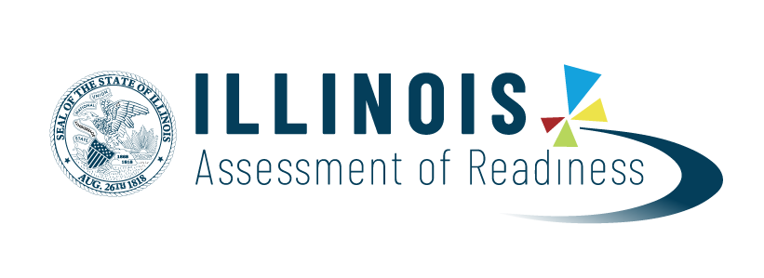

New for 2021: Parent Portal and Video Individual Score Reports
Illinois Assessment of Readiness for English Language Arts/Literacy (ELA/L) and Mathematics

Dear Parent or Guardian:

(Insert School/District Name) is pleased to inform you of a new and innovative method for presenting your student Illinois Assessment of Readiness (IAR) test results.

- IAR Parent Portal – Introducing https://il-results.pearsonaccessnext.com, where you can access individual student results and resources to support everything you need to know about your child's performance on the Illinois Assessment of Readiness for English Language Arts and Math. This portal also allows you to add your student’s Spring 2021 test results to your user account and access them in the future.
- Video Individual Score Reports (Video ISRs) – Video ISRs are personalized videos created specifically for your student that walk through the information presented on their student's score report. Delivered via the IAR Parent Portal, video ISRs combine student-specific animation and voiceovers to help you better understand your student’s assessment results and direct you to resources that are tailored for your student's needs. We encourage you to watch these videos with your child and discuss any questions with your student’s teacher.

As in the past, you will continue to receive paper copies of the Individual Student Reports (ISRs). However, new this year, included on the ISR, will be an individual claim code unique to your student. With this code you will be able to securely access your student’s test results in the IAR Parent Portal.

The IAR Parent Portal and Video Individual Score Reports will be available October 26, 2021.

We are excited about the opportunity to strengthen our efforts with you to effectively communicate your student’s performance on the Illinois Assessment of Readiness.

Sincerely,

(Chief School Administrator or School Principal’s Name)

